Walkthrough 12 Shell Control as Container

https://sapui5.hana.ondemand.com/#/topic/4df1d914e52d4b1aa0805eb01522537e

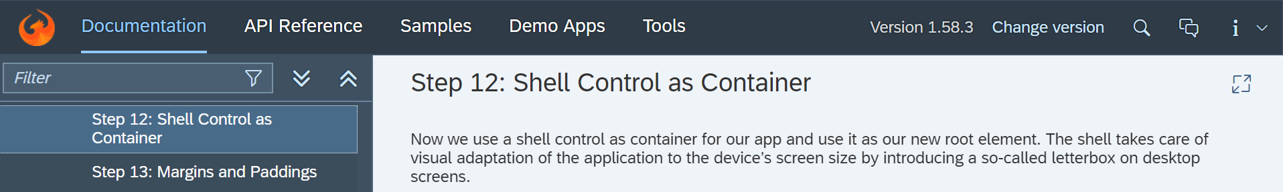

Core Changed Codes Compared to Last Version:

Index.html

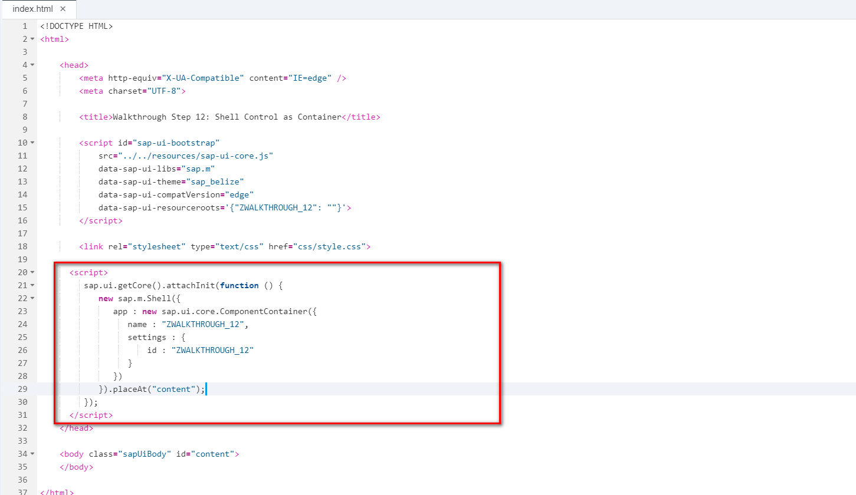

I18n

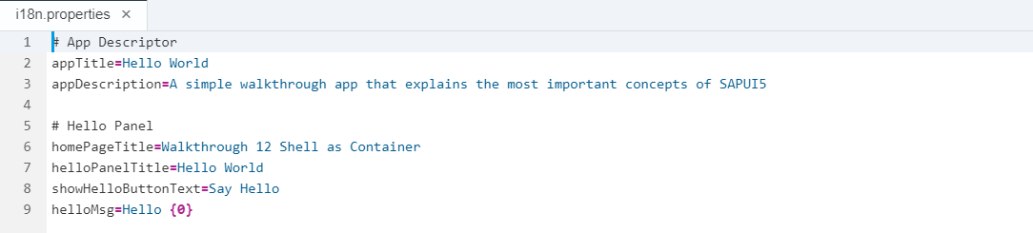

Result:

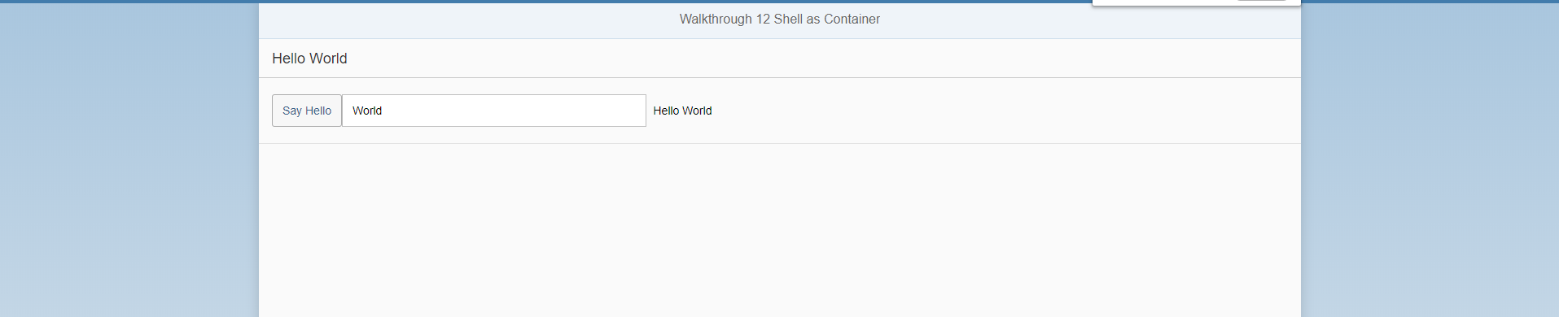

Git:

WALKTHROUGH_12

2018/11/02 XiaoMi Beijing Zac,Xie